**1Excel Skills for Business - специализация**

**Excel Skills for Business: Essentials - 1 курс**

### Тест 1

1.1The large toolbar that stretches across the top of the Excel window is known as the **Excel bar (false)**

1.2 The large toolbar that stretches across the top of the Excel window is known as the **Ribbon**.

**(true)**

2.1The Excel Ribbon can be minimised or collapsed by double-clicking (single-clicking for Mac) on one of the Ribbon Tabs.  
**(true)**

3.1Columns are referenced using numbers.

**(false)**

3.2 Columns are referenced using letters of the alphabet.

**(true)**

4.1 Rows are referenced using letters of the alphabet.

**(false)**4.2Rows are referenced using numbers.

**(true)**

5.The first cell (top-left) in a standard Excel spreadsheet is known as **1A**.

**(false)**

6.1Cell A2 is to the left of cell A3.

**(false)**

6.2 Cell **A2** is above cell **A3**.

**(true)**6.3 Cell B2 is to the right of cell A2.  
**(true)**

7.1 Cells D1, D2, D3, ..., D20 are all in the same column.

**(true)**7.2 Cells A1, A2, A3, ..., A20 are all in the same row.

**(false)**

8.1 The Quick Access Toolbar can be shown above or below the ribbon

**(true)**8.2 The Quick Access toolbar can be customised to show the tools you use most often.  
**(true)**9.1Clicking on cell C3 and clicking Freeze Panes will freeze the top 3 rows and the first 3 columns.  
**(false)**  
9.2 Clicking on cell **C3** and clicking **Freeze Panes** will freeze all rows above **C3** and freeze all columns to the left of **C3**.  
**(true)**

10.1You can navigate to the right-hand side of your spreadsheet using the scroll bars on the bottom right of the Excel window.  
**(true)**  
10.2 You can navigate to the right-hand side of your spreadsheet using the arrow keys of the keyboard.  
**(true)**10.3You can navigate to the right of your spreadsheet by scrolling the scroll wheel of your mouse. **(false)**11.1You can directly type into a cell by clicking on it and proceeding to type.  
**(true)**  
11.2 If you notice an error in a cell, you can move the cursor to the location of the error within a cell by double-clicking the desired location.  
**(true)**11.3 If you notice an error in a cell, you can move the cursor to the desired location in the formula bar.  
**(true)**  
11.4 If you notice an error in a cell, you can correct it by typing over the error.  
**(true)**

12 If you are typing some text that has already been entered in the same column, Excel will recommend this as a suggestion for you.  
**(true)**13.1You cannot copy and paste numbers into Excel from another Office software such as Microsoft Word. **(false)**13.2 You cannot copy and paste text into Excel from another Office software such as Microsoft Word.  
**(false)**13.3You can copy and paste in Excel in a similar way to how you can copy and paste in Microsoft Word.  
**(true)**14.If you want to remove some information from your spreadsheet, you can highlight this information and press Delete.  
**(true)**15.1 It is impossible to reverse more than one task at a time in Excel using the **Undo** tool.  
**(false)**

15.2 If you want to reverse most previously conducted tasks, you can click the Undo button at the top left of the Excel window.  
**(true)**Тест 2

1.1 How many columns in an Excel worksheet (version 2007 and later)?  
**(16,384)**

2.1 In a blank Excel workbook, go to the Insert tab on the ribbon. Which of the following is NOT available?  
**(Columns)**

3.1 In cell A1 type in the heading Date then press Enter. In cell A2 type in the following: 20-Jan-20. Use the fill handle to drag the date you have just typed down to row 20. What is the date in A15? Enter as shown or use Year-Month-Day format if you are not using an English version of Excel (for example 2020-01-20).  
**(2020-01-28)**

4.1 In cells **B1** to **B3** enter the following:

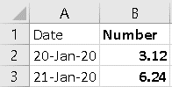

Select cells **B2** and **B3** then use the fill handle to drag down to row 20. What is the value in **B15**?  
**(not 18.72)**

**(43.68)**

5.1 Close your workbook without saving and open the attached workbook. What value is in cell **Q83** on the **Orders** sheet?  
**(13)**  
5.2 Close your workbook without saving and open the attached workbook. What value is in cell **Q101** on the **Orders** sheet?  
**(49)**

6.1 How many worksheets in this workbook?  
**(3)**

7.1 Go to the **Sales 2016** worksheet. Which cell contains the heading **Qtr4**?  
**(E3)**7.2 Go to the **Sales 2016** worksheet. Which cell contains the heading **Qtr2**?  
**(C3)**

8.1 Still in **Sales 2016**, select the range **B8:E10**. Look at the status bar at the bottom of the screen. You should see **Sum** followed by a number. What is the number?   
(Hint: the range **B8:E10** means to select all of the cells between **B8** and **E10**. We go into this in more detail next week.)  
**(50933.77)**

9.1 Select the two non-contiguous ranges (not next to each other) **C8:C11** and **E8:E11**. What is the **Average** showing on your status bar for the two ranges?  
**(5549.49)**   
9.2 Select the two non-contiguous ranges (not next to each other) **B4:B7** and **D14:D17**. What is the **Average** showing on your status bar for the two ranges?  
**(5371.10)**

10.1 Change the value in **C13** to be 4675.24. What is the new value in **C18**?  
**(62119,27)**  
10.2 Change the value in **D6** to be 1033.5 What is the new value in **D18**?  
**(62277.02)**  
  
Тест 3

1.1 Open the attached workbook. In F7 calculate Base Pay by multiplying the Hours by the Rate. Copy the formula down to F12. What is Sophie Yang's Base Pay for the week?  
**(1083.00)**1.2 In H7 calculate Gross Pay by adding Base Pay and Commission. Copy the formula down to H12. What is Diepak Kumar's Gross Pay for the week?  
**(1184.00)**

2.1 In G7 calculate the Commission amount by multiplying the Base Pay by the Commission Rate. Copy the formula down to G12. What is Sandy Smith's Commission for the week?  
(**47.36)**

2.2 In G7 calculate the Commission amount by multiplying the Base Pay by the Commission Rate. Copy the formula down to G12. What is Diepak Kumar's Commission for the week?  
**()**

3.1 In H7 calculate Gross Pay by adding Base Pay and Commission. Copy the formula down to H12. What is Diepak Kumar's Gross Pay for the week?  
**(1037.40)**  
3.2 In H7 calculate Gross Pay by adding Base Pay and Commission. Copy the formula down to H12. What is Steve Welgemoed's Gross Pay for the week?  
(**409.34)**

4.1 In I7 calculate Tax by multiplying Gross Pay by Tax Rate (in this instance all staff are on the same tax rate). Copy the formula down to I12. What is John McGregor's Tax for the week?  
**(299.35)**4.2 In I7 calculate Tax by multiplying Gross Pay by Tax Rate (in this instance all staff are on the same tax rate). Copy the formula down to I12. What is Diepak Kumar's Tax for the week?  
(**290.47)**

5.1 In J7 calculate Net Pay by subtracting Tax from Gross Pay. Copy the formula down to J12. What is Steve Welgemoed's Net Pay for the week?  
**(294.73)**

5.2 In J7 calculate Net Pay by subtracting Tax from Gross Pay. Copy the formula down to J12. What is Sophie Yang's Net Pay for the week?

(810.95)  
  
6.1 In cells F14:J14 calculate totals for each of the columns. What was the total Gross Pay?  
(5358.39)

7.1 In cells F16:J16 calculate an average for each of the columns. What was the Average Net Pay?  
**(643.01)**

7.2 In cells F16:J16 calculate an average for each of the columns. What was the Average Commission?  
**(34.35)**

8.1 In cells F17:J17 calculate the maximum for each of the columns. What was the Maximum Tax?  
**(344.78)**

8.2 In cells F17:J17 calculate the maximum for each of the columns. What was the Maximum Gross Pay?  
**(1231.36)**

9.1 In cells F18:J18 calculate the minimum for each of the columns. What was the Minimum Tax?  
**(114.62)**

9.2 In cells F18:J18 calculate the minimum for each of the columns. What was the Minimum Commission?

()

10.1 Click into the Branch Summary worksheet. First, we want to calculate the Total Commission for Edenvale (see the Branch column on both sheets). In B6 type in =SUM( then click into Pay Details and select G7:G9, then press Enter. Repeat the process, selecting the appropriate cells, to get the Total Commission for Sandown.  
Use the fill handle to get Total Gross Pay for Edenvale and Sandown. What was the Total Gross Payfor Edenvale?  
**НЕ (77.71)**

Тест 4  
1.1 Sean wants to make a change in cell B2, but every time he clicks on the cell, A1 becomes the active cell instead.

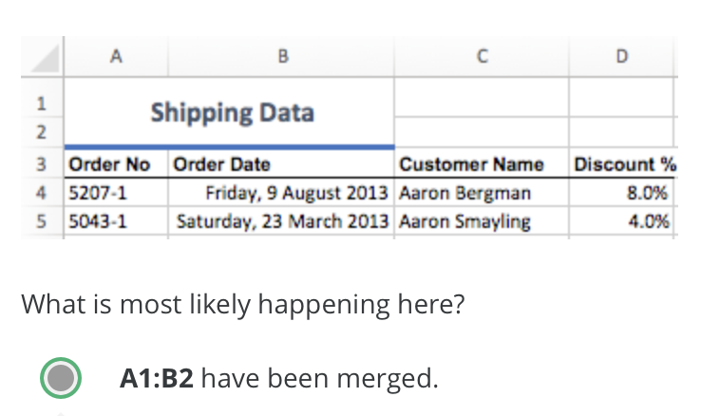  
**(ХЗ, картинки разные могут быть!)**

2.1 Open the attached workbook and observe how the heading in row 1 has been formatted. What size font is the heading?  
**(36)**2.2 Open the attached workbook and observe how the heading in row 1 has been formatted. What is the name of the font used in the heading?  
**(хз)**

3. Which alignment option has been applied to the heading in row 1?  
(**Merge and Center)**

4.1 Which alignment options have been applied to cell A3?  
(One or more answers are possible — partial credit will be awarded) **Middle Align**4.2 Which formatting options have been applied to cell A3?  
(One or more answers are possible — partial credit will be award  
**Bold  
Italic  
Middle Align**

5.1 The date in B3 has lost its formatting. Apply a Long Date format. What **day** of the week was this data last modified?  
(**Saturday)**5.2 The date in B3 has lost its formatting. Apply a Long Date format. What **month** of the year was this data last modified?  
**June**

6. The percentages in T9 and T10 also have the wrong number format. Change them to the correct number format (to match the rest of the data in the column). What value now shows in T9? **(92.50)**  
6.1 The percentages in T9 and T10 also have the wrong number format. Change them to the correct number format (to match the rest of the data in the column). What value now shows in T10? **(60)**

7. Which Cell Style has been added to cells C38:U38? (Hint: Look in the Cell Styles gallery, when you hover over a style it tells you the name.)  
**(Total)**

8. Which of the following formats has been added to B3?  
**Thick Bottom Border**

9.1 Which alignment option has been applied to the headings in D6:T6?  
**Wrap Text  
Rotate Text Up**

9.2 Which format options have been applied to the headings in D6:T6?  
(One or more answers are possible — partial credit will be awarded)  
**Bold  
Center  
Rotate Text Up**

10. Which alignment option has been applied to cell U31?

**Wrap Text**

11. Click on cell S38 and increase the number of decimal places to 3. What is the value in the cell now? (Enter using the number format ##.###).

**(30.867)**

Тест 5  
  
1.1 You want to insert 3 columns. Which of the options below will help you to achieve that?  
*Multiple answers are possible. Partial credit will be awarded.* **(You select 3 columns, right-click and go to Insert)  
(You select a column then click the Insert button on the Home tab 3 times)**

2.1 Sean has carefully set up some complicated Conditional Formatting to one of the columns in his worksheet. He now wants to apply the same rules to another column in his worksheet. What is the quickest way for him to do this?  
(**He can use the Format Painter)**

3.1 Open the attached workbook. You will notice that some columns have been hidden. Unhide the columns. What is the Product Category for order 5019-1?  
**(Technology)**3.2 Open the attached workbook. You will notice that some columns have been hidden. Unhide the columns. What is the Product Name for order 5023-1?  
**(Pencils)**

4.1 Order 5024-1 was cancelled. Delete row 11 (not just the data). What is the updated average in cell S1? (Please put the number only, no currency symbols)  
**(1156.53)**

5.1 You need to find out about the most recent shipment. Sort the data by Ship Date. What was the Order Quantity for the most recent item?  
**(31)**5.2 You need to find out about the most recent shipment. Sort the data by Ship Date. What was the Ship Date for the most recent item? Enter using yyyy-mm-dd format.  
**(08.02.2017)**

6.1 You need to check the most recent furniture item. Sort the data by Product Category (A-Z) and then Order Date (Newest to Oldest). What is the Order Priority for the most recently ordered Furniture Item?  
 **(Low)**6.2 You need to check the most recent furniture item. Sort the data by Product Category (A-Z) and then Order Date (Newest to Oldest). What is the Customer Type for the most recently ordered Furniture Item?  
(**Corporate)**

7.1 You have been asked to find out about orders placed by the customer Cindy Chapman. Filter the data to show only her orders. How many orders had Tina Carlton as the Account Manager?  
**(6)**7.2You have been asked to find out about orders placed by the customer Cindy Chapman. Filter the data to show only her orders. How many were High Priority? **(1)**  
  
8.1 Clear the previous filter. Use filters to find out how many orders were for Home Office customers, where the Account Manager is Leighton Forrest, with a High priority.  
**(3)**8.2 Clear the previous filter. Use filters to find out how many orders were for Small Business customers, where the Account Manager is Natasha Song, with a High priority.  
**(5)**

9.1 Clear the previous filters. Use filters to find out how many orders were for Technology and had a Total over $20,000.  
**(10)**9.2 Clear the previous filters. Use filters to find out how many orders were for Office Supplies and had a Total over $7,000.  
**(5)**

10.1 Clear the previous filters. Apply a new filter to show the top 1% of orders by Total. What is the Average Quantity for the top 1% (cell M1043).  
**()**

11.1 Use the find tool to find order number 6044-1. What is the Quantity for this order?  
**(26)**11.2 Use the find tool to find order number 6044-1. What is the Priority for this order?  
**(Medium)**

12.1 Tina Carlton has recently married and has chosen to take her partner's name. Start by clicking in cell A1. Use Find and Replace to replace all instances of Tina Carlton with Tina Shaw. Check the message — how many replacements were made?  
On a Mac, go to the Edit menu > Find > Replace.  
**(137)**  
  
Тест 6  
  
1.1 The attached workbook is needed to answer all the questions associated with this quiz. Open the attached workbook and investigate what this document will look like when printed (do not actually print). How many pages will print?  
**(3)**

2.1 What Margin setting has been selected? **(Narrow)**

3.1 Which Orientation has been selected?  
(**Landscape)**4.1 A Custom Scale has been applied.  
(**True)**

5.1 How many page breaks have been added?  
For Mac users, switch to the Page Layout view, then back to Normal to see the page breaks. Manual page breaks will still be dotted lines.  
**()**

6.1 If we wanted to insert another page break between rows 20 and 21 we would need to click on which cell first? (We only want to add a horizontal page break). For your answer, enter a cell reference e.g. B5.  
(**A21)**

7.1 For the printed version of the page, based on the existing setup, which of the following is true? (One or more answers may be correct) **(A page number has been added to the footer)**  
  
8.1 For the printed version of the page, based on the existing setup, the first four rows repeat on every page. To stop this we would: **(Adjust settings in Print Titles)**

9.1 If we insert a column between C and D which of the following happens? (One or more answer may be correct)  
(**The custom scaling changes)**

10.1 Before we can manually change the custom scaling, we must: **(Set Page Width to Automatic)**

Тест 7  
  
1.1 Creating charts is pretty straightforward but it's important we know the terminology Excel uses. What is the Chart Area?  
**(The chart area is the entire chart with all of its elements.)**

2.1 Creating charts is pretty straightforward but it's important we know the terminology Excel uses. What is the Plot Area?

**(The plot area is the part of the chart that displays the data visualization. It is located in the area framed by the y and x axis.)**

3.1 Creating charts is pretty straightforward but it's important we know the terminology Excel uses. What is meant by the word Legend?

**(The legend decodes the data labels and adds explanation to the chart.)**

4.1When you want to create a chart, what do you need to observe?

*Multiple answers are possible, partial credit will be awarded.*

**(ALL)**

**Ensure that your selection doesn't contain any empty rows or columns.**

**Carefully select all the data you want to include in the chart.**

**Select any headings in rows and/or columns.**

5.1 Download the workbook below. It contains a slightly altered and abbreviated version of the FBI Crime Statistics, 1994-2013. You will need to work with it in order to answer the next questions in this assignment.

[W06-workbook.xlsx](https://d3c33hcgiwev3.cloudfront.net/_bf1081c4d92b2c747b15c94d26543c4b_W06-workbook.xlsx?Expires=1538524800&Signature=aLqfPlCJ-ABBsPQd~WWgkEOhkXCqX9QcJiT6p291QglJ9XL59UjIEhTruKYPiylq~kUMdSQmG1jlmyffAw9RCApg-XOPQaDflo~AErZXS8M~U7XzHyody5X1Dixg8jcJTR6Ve1Ismu3j3yJDpP6KSH2bVKChRBf7MM1RNspV738_&Key-Pair-Id=APKAJLTNE6QMUY6HBC5A)

You have been given the task to provide some visual summaries to support a presentation on trends and volume of certain types of crime in the United States. Take a moment to familiarize yourself with the workbook. What is the title of Table 1?

(**Crime in the United States by Volume, 1994-2013)**

6.1Take a look at the screenshot below and then head over to Excel to your W06-workbook file. Which cell ranges were selected to create this chart?

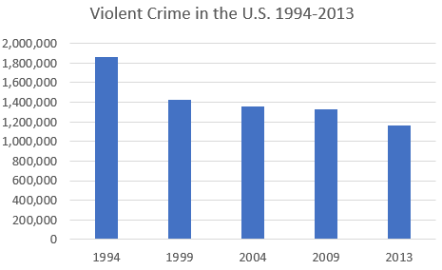

**(A4:B9)**

7.1Take a look at the screenshot below. What type of chart is this?

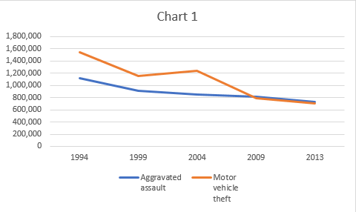

If you are unsure, go over to Excel and have a play with the different chart types to figure out which one we are seeing here.

**(A line chart.)**

8.1 Take a look at the chart below. What's missing from this chart to make it a useful visualization for a presentation on Violent Crime rates between 1994-2013?

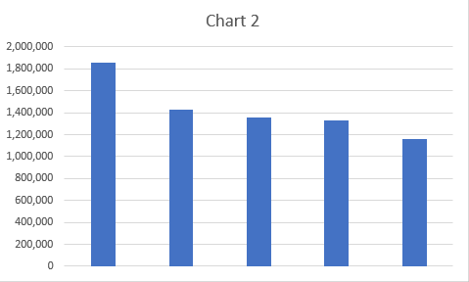

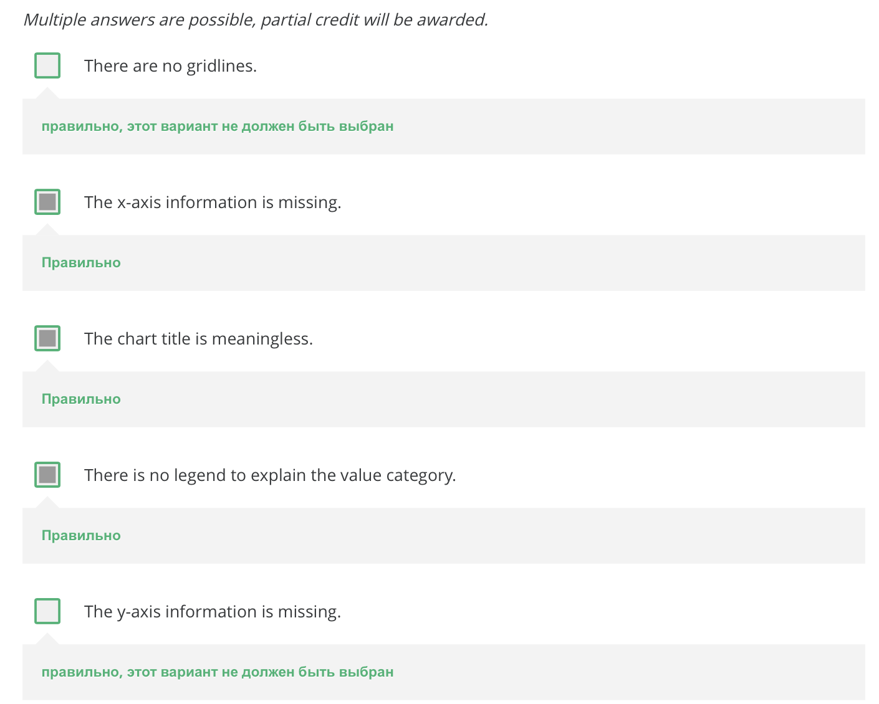

9.1 Using the data in the W06-workbook, create a 2-D Pie Chart for 2004. Which of the following best represents what you have created?

**(This:ДАНЯ)**

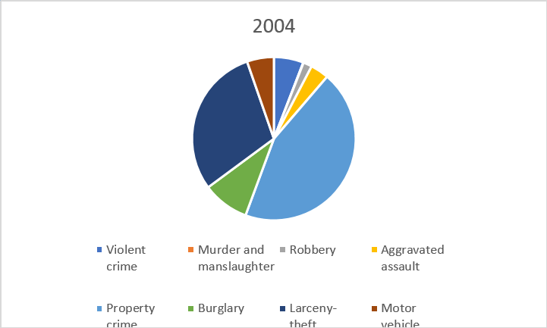

10.1 Create a Line Chart for Violent crime, Burglary and Motor vehicle theft. Use the Quick Layout to show the data table below the chart (hint: hover over the Quick Layout options to find which one includes a data table). Change the colors so that Violent crime is green, Burglary is blue and Motor vehicle theft is yellow. Change the chart title to Crime in the USA 1994-2013. Change the vertical axis label to be Number of crimes.

Which of the following does your chart most closely resemble

**(This:)**

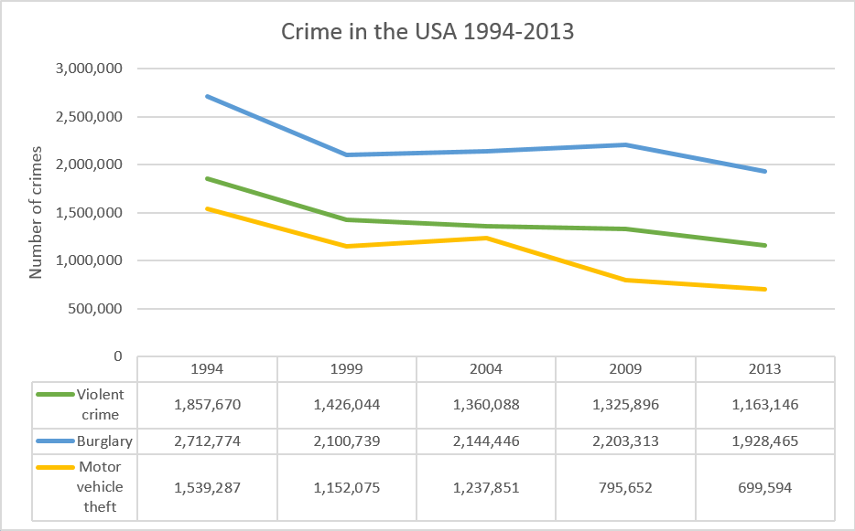

Тест 8 (Course 1 Final Assessment)  
  
1.1 The workbook contains data downloaded from a government database. It is not very easy to read, so your first job is to address some of the formatting.  
The heading in cell A1 cannot be seen properly. Change the alignment so that you can see what it says.  
In which year was this data collected?  
**(2015)**

2.1 Somehow the date in cell B2 has lost its formatting. Change the format to a date. What date is now shown in B2? **(20-03-2016)**

3.1 Apply the style Accent1 to the range A2:Z2. Apply the style Heading 3 to the range A4:Z4. Which of the following looks most like your data?  
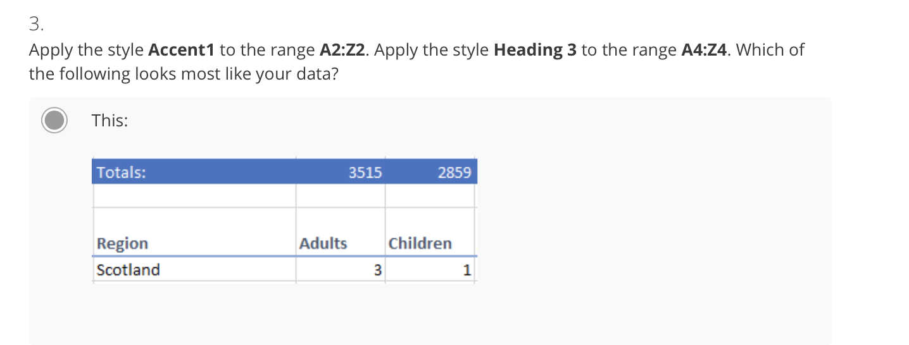4.1 There are also some corrections you need to make to the data. One of the data entries is missing. You have been asked to Insert a row after Case ID 49 (row 15) and enter the following data:  
What is the total March Expenditure now? (cell Q2)  
**(4429863,16)**  
4.2 QUESTION: What is the total February Expenditure now? (cell P2)  
**(4307242,05)**5.1 An incorrect value has been entered for Case ID 5299. Use the Find tool to find this Case ID and change the January Income to $200. What is the total January Income now? (cell I2)  
**(6074344,46)**

6.1 There are several calculations missing which need to be added. An additional column showing the total number of people per household is required. Perform all the following steps and then answer the question.

1. Insert a column after column H
2. In I4 type the heading Household
3. In I5 enter a calculation to add the number of adults in G5 to the number of children in H5
4. Copy the formula down to fill the column
5. In cell I2, enter a calculation to get the total number of people in all the households represented, or copy the formula across from cell H2

QUESTION: What is the total Household value in cell I2? **(6378)**

7.1 In cell V5 enter a calculation to get an average of income from January to June (J5 to O5). Copy the formula down the column. What is the Average Income for Case 20 (cell V10)?  
**(4019,36)**7.2 In cell V5 enter a calculation to get an average of income from January to June (J5 to O5). Copy the formula down the column. What is the Average Income for Case 15 (cell V8)?  
**(3936,27)**7.3 In cell V5 enter a calculation to get an average of income from January to June (J5 to O5). Copy the formula down the column. What is the Average Income for Case9 (cell V6)?  
**(3323,88)**

8.1 In cell W5 enter a calculation to add up the total income from January to June. Copy the formula down the column. Widen the column so that you can see the results. What is the total income for Case 9 (cell W6)?  
**(19943,28)**8.2 In cell W5 enter a calculation to add up the total income from January to June. Copy the formula down the column. Widen the column so that you can see the results. What is the total income for all the cases (cell W2)?  
**(36459734,19)**9.1 In cell X5 enter a calculation to add up the total expenditure from January to June (P5 to U5). Copy the formula down the column. What is the total expenditure for Case 9?  
**(10709,83)**9.2 In cell X5 enter a calculation to add up the total expenditure from January to June (P5 to U5). Copy the formula down the column. What is the total expenditure for Case 20?  
**(6692,18)**

9.3 In cell X5 enter a calculation to add up the total expenditure from January to June (P5 to U5). Copy the formula down the column. What is the total expenditure for Case 15?

*In your answer, you should use the number format #####.##*

()

10.1 In cell Y5 enter a calculation to subtract Total Expenditure from Total Income. Copy the formula down the column. What is the Net for Case 15?  
**(10862,77)**10.2 In cell Y5 enter a calculation to subtract Total Expenditure from Total Income. Copy the formula down the column. What is the Net for Case 20?  
**(17423,96)**

10.3 In cell Y5 enter a calculation to subtract Total Expenditure from Total Income. Copy the formula down the column. What is the Net for Case 9?  
**(9233,45)**

11.1 Cost of living has been estimated at going up by 3.93% over the next 6 months. We would like to forecast what the expenditure will be over that period. In cell Z2 enter the value 3.93%. In Z5 enter a formula to calculate the forecast expenditure. To do this you will need to calculate the increase in expenditure (current total expenditure multiplied by the percentage increase) and add it to the current total expenditure. Copy the formula down the column. (Make sure that all the calculations are using the value in Z2!).  
QUESTION: What is the Forecast Expenditure for Case 15?  
**(13256,09)**11.2 Cost of living has been estimated at going up by 3.93% over the next 6 months. We would like to forecast what the expenditure will be over that period. In cell Z2 enter the value 3.93%. In Z5 enter a formula to calculate the forecast expenditure. To do this you will need to calculate the increase in expenditure (current total expenditure multiplied by the percentage increase) and add it to the current total expenditure. Copy the formula down the column. (Make sure that all the calculations are using the value in Z2!).  
QUESTION: What is the Forecast Expenditure for Case 20?  
**(6955,18)**11.3 Cost of living has been estimated at going up by 3.93% over the next 6 months. We would like to forecast what the expenditure will be over that period. In cell Z2 enter the value 3.93%. In Z5 enter a formula to calculate the forecast expenditure. To do this you will need to calculate the increase in expenditure (current total expenditure multiplied by the percentage increase) and add it to the current total expenditure. Copy the formula down the column. (Make sure that all the calculations are using the value in Z2!).  
QUESTION: What is the Forecast Expenditure for Case 9?  
**(11130,73)**

12.1 Now select the Stats Worksheet. Enter simple formulas in B3 and B4 to pull through the calculated Total Expenditure and Total Net from the Data worksheet (cells X2 and Y2). If you have done it correctly the pie chart should now show how income is proportioned between expenditure and net.

QUESTION: According to the pie chart, what percentage of Income is made up by Net?   
*Do not enter the % symbol in the answer box below, just the number.***(25)**

12.2 Now select the Stats Worksheet. Enter simple formulas in B3 and B4 to pull through the calculated Total Expenditure and Total Net from the Data worksheet (cells X2 and Y2). If you have done it correctly the pie chart should now show how income is proportioned between expenditure and net.

QUESTION: According to the pie chart, what percentage of Income is made up by Expenditure?

*Do not enter the % symbol in the answer box below, just the number.*

**()**13.1 Still on the Stats sheet, enter a formula in B5 to add up the total income for Quarter 1 using the calculated totals for January, February and March in the Data worksheet. If you have done it correctly the cell should change colour.   
QUESTION: What colour is the cell B5?  
**(Purple)**

14.1 The organisation has decided to have one Region for the Midlands instead of two, so both East Midlandsand West Midlands need to be replaced with just Midlands. We then need to answer some questions for the organisation.  
In the Data worksheet, use Find and Replace to replace all instances of East Midlands with Midlands. Repeat the operation, this time replacing West Midlands with Midlands. Now filter the data so that only cases from the Midlands are visible.  
QUESTION: What is the total number of Adults recorded for the Midlands?  
**(629)**

15.1 Clear the previous filter. Add filters so that we only see cases for Wales with 6 or more people in the household.   
QUESTION: How many households in Wales have 6 or more people?  
**(1)**16.1 Clear all filters. Sort the data by Total Income in descending order (largest to smallest).   
QUESTION: What is the highest Total Income for a case?  
*In your answer, you should use the number format #####.##***(40001,26)**16.2 Clear all filters. Sort the data by Total Income in descending order (largest to smallest).   
QUESTION: Which Case ID has the highest Total Income?  
**(566)**  
17.1 Change the sort to order the data so that you can easily identify the lowest Average Income for Cases with an Intermediate occupation.   
QUESTION: What is the lowest Average Income for people with an Intermediate occupation?  
*In your answer, you should use the number format #####.##***(18,35)**

18.1 You are concerned there may be duplicates in the data set. Add conditional formatting to the Case IDcolumn to show all duplicates in red. Sort the data by Case ID but instead of by values, sort by colour.   
QUESTION: How many cases have been duplicated (entered twice)? **(2)**19.1 Delete one of each of the duplicate rows.   
QUESTION: What is the new total in G2?  
**(3513)**20.1 To help represent the data graphically you have been asked to create a few charts. You will need to go back to the Stats worksheet.  
Select the data from A8 to B12. Insert a Pie Chart to compare the Average Incomes for different Economic Positions. Add a quick layout that shows a percentage for each segment.  
QUESTION: What is the percentage for Economically Inactive?   
*Do not enter the % symbol in the answer box below, just the number.***(27)**21.1 Create a line chart showing the Total Income for each Month. Ensure you select month names and Total Income values.   
QUESTION: Which of these charts looks most like your line chart?  
**(This:**

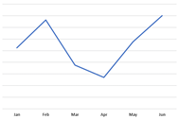

22.1 Insert a Stacked Column Chart to show the Jan, Feb and Mar income for each Region. QUESTION: Which Region has the fourth highest income for Jan-Mar (fourth largest stack)? **НЕ Midlands**

Excel Skills for Business: Intermediate I - курс 2

**Тест 1 Test your Skills: Working with Multiple Worksheets & Workbooks**

1. Ensure you have downloaded all the C2 W1 Assessment workbooks. Open the workbook C2 W1 Assessment Sales Di. Move the worksheet called Q1 Summary to the front of the other worksheets. In the Q1 Summary worksheet click in cell C5, use 3D formulas to summarise the total quantity sold of item 3243 for January to March. How much commission did Di earn on this item?   
**(81.49)**

2. Copy the formula in C5 down to C14. What was Di's total commission?   
**(3356.42)**

3. Open C2 W1 Assessment Sales Lemin and C2 W1 Assessment Sales Summary. In Sales Lemin note all the commissions are comi ... click in F4 in Sales Lemin and use a linking formula to pull the commission rate through from Sales Summary. In Sales Lemin return to the Q1 Summary, what is the updated Total Commission?   
**(7908.61)**

4. Open C2 W1 Assessment Sales Aneesha. You will see a message informing you of broken links, this is because the commission rate is still linked to the old sales summary. The link will need to be updated to look at the rate in C2 W1 Assessment Sales Summary. After updating the link what is Aneesha's Q1 Commission?  
**(14793.19)**

5. **сань, хуй саси**

**Тест 2 Test your Skills: Text and Date Functions**

1.1 It is necessary to provide more meaningful labels for boxes of items in stock. The first tab of the attached workbook contains the inventory items. You will need to generate the information needed on the For Printing tab using a range of text functions.  
On the Inventory tab enter a formula in J1 that will return the current date but not time. What function did you use?  
(**TODAY)**

2.1 In J4 calculate the number of days since the last order, copy the formula down to J35. What is the check digit value in G1?

**(17)**

3.1 In the For Printing worksheet in A5, generate a part code using SKU- followed by the Material Code, another "-" and the Part Number, e.g. SKU-07-2425. Copy the formula down. What is the value for Check Digit 1 (cell H5)?

**()**

4.1 In B5 we need to see the material in upper case. Copy the formula down. What is the value for Check Digit 2 (cell H6)?

**(5827)**

5.1 In C5 we want to create a Distributor Code, which is the first 5 characters of the Distributor Name. Which function did you use?

**(LEFT)**

6.1 To avoid confusion, make a change to the formula in C5 so that all Distributor Codes show in all lower case. Copy the formula down. What is the value for Check Digit 3 (cell H7)?

**(6275)**

7.1 Many of the part descriptions are too long, so in D5 create a calculation to get the first 8 characters of the part description and then copy the formula down. That's not ideal, so we want to change it to get all the text to the left of the first comma. Which function will allow us to locate the position of the first comma?

**(FIND)**

8.1 Change the calculation in D5 to retrieve the part description up to the first comma. Copy the formula down. What is the value of Check Digit 4?

**(3203)**

9.1 The Distributor Address is in the format: "Street Address, Postcode, State". In E5 enter a calculation that will retrieve just the post code from the Distributor Address. Which of the following combination of functions could you use to achieve this?

**(MID и FIND)**

10.1 Change the calculation in E5 to also include the State before the postcode, e.g. NSW2007. Copy the formula down. What is the value of Check Digit 5?

**()**

**Тест 3 Named Ranges**

1.1 A travel expenses template has been compiled for your company to make it easier for staff to record their expenses when travelling to branches in other countries. It has recently been updated and the named ranges have been damaged in the process so most of the formulas are returning an error. You need to correct the named ranges to fix the problem.

Have a look at the Travel Expense worksheet. Note there are quite a few errors. Start by addressing the problem of the missing exchange rates by naming the ranges. Go to the Currency Ratesworksheet and use Create from Selection to name all the rates (A4:B12) using the labels in column A.

What value is now showing for the Other Expenses in K6?  
**(15.76)**

2.1 While the calculation of Other Expenses is looking better it is still not correct. Open the Name Manager. There is a range called Coffee that is no longer used, so delete it. Now have a look at Ex_Rate, it only goes to row 14, which explains the incorrect calculation. Edit it to go from L11:L21. Click OK and close the Name Manager.

What is the corrected value for Other Expenses in K6?  
**(27.49)**

3.1 Let's fix Travel Costs next. Open the Name Manager, there is a named range called Travel_Costs, but this is the wrong name, change it to TravelCosts and click OK and close the Name Manager.

What is the corrected value for Transportation Expense in K3?  
**(495.27)**

4.1 Next, Lodging Costs. Use any method you think suitable to give the name Lodging_Costs to range F11:F21. What is the corrected value for Lodging Expense in K4?

**(2546.41)**

5.1 And now to fix meals, let's be efficient and use Create from Selection to name all three ranges simultaneously. Select G10:I21 and click Create from Selection. What is the corrected value for Meal Expense in K5?

**(1279.42)**

6.1 Our Travel Expense worksheet is now looking good, but we would also like to complete a breakdown of expenses by region. Start by adding the following named ranges:

* E11:J14- London
* E15:J18- Paris
* E19:J21- Mumbai

Now go to the Summary By Region worksheet and observe the calculated values for London. What was the total amount spent in London in Pounds (C4)?  
**(1728.56)**

6.2 Our Travel Expense worksheet is now looking good, but we would also like to complete a breakdown of expenses by region. Start by adding the following named ranges:

* E11:J14- London
* E15:J18- Paris
* E19:J21- Mumbai

Now go to the Summary By Region worksheet and observe the calculated values for London. What was the total amount spent in London in USD (D4)?

**NO(1904.91)**

7.1 Enter a formula in C5 to add up the total amount spent in Paris (use the named range you have just created). Then do the same in C6 for Mumbai.

What was the total amount spent in Mumbai in Rupees (C6)?  
**(24190.02)**

7.2 Enter a formula in C5 to add up the total amount spent in Paris (use the named range you have just created). Then do the same in C6 for Mumbai.

What was the total amount spent in Paris in Euros (C5)?

**(1450.43)**

8.1 In D5 create a calculation to convert Euros to Dollars by multiplying the Euros spent (C5) by the exchange rate for Euro (which is named EUR). Perform a similar calculation to convert the Indian Rupees to Dollars.

What was the total USD spent in Mumbai?  
**(377.12)**

8.2 In D5 create a calculation to convert Euros to Dollars by multiplying the Euros spent (C5) by the exchange rate for Euro (which is named EUR). Perform a similar calculation to convert the Indian Rupees to Dollars.

What was the total USD spent in Paris?

**(1701.28)**

9.1 Click in D7 and use Autosum to get the total spent in USD. If we were to now name the range D4:D6, would the formula just created in D7 automatically change to use the named range? You should not actually create this named range.

**(No, but you could use the Apply Named Range to apply it.)**

10.1 Click in B9 (still in Summary By Region), and use the Paste Names tool to Paste all the named ranges into your workbook. What value is in B25?

**(Paris)**

10.2 Click in B9 (still in Summary By Region), and use the Paste Names tool to Paste all the named ranges into your workbook. What value is in B23?

**(NZD)**

# 4 Test your Skills: Summarising Data

1.1 Use Create from Selection to name each of the columns of data in the Ealing Property Sales sheet.

Check the Name Box to see all your named ranges have been created correctly. What name has been applied to the data in Column D?

**(Year_Sold)**  
2.1 In C3 use a COUNT function to count the values in the named range ID.  
  
What answer does the COUNT function return?  
  
Please enter just the number.  
**(9)**  
  
3.1 This is not the result we were hoping for, look carefully at the ID column, can you see why we got this answer?

Which function should you use if you wanted to pick up all the IDs?  
**(COUNTA)**

3.2  
***(Because some IDs contain text characters)***

4.1 Have a look at column J (Flat Number), note that a lot of the cells are blank.

Which function would you use to count the number of blank cells in a column?  
*Please enter just the function name all in UPPERCASE letters with no equal sign, brackets or arguments.***(COUNTBLANK)**

5.1 On the Summary Data sheet, in cell B4, use a function to sum the Price Paid for all properties of type Terraced. Copy the formula down.

What was the total **Price Paid for Semi**? Don't enter the currency symbol or decimal points, just the plain number of the format #####  
**(72906550)**

5.2 On the Summary Data sheet, in cell B4, use a function to sum the Price Paid for all properties of type Terraced. Copy the formula down.

What was the total **Price Paid for Terraced**? Don't enter the currency symbol or decimal points, just the plain number of the format #####  
**(**134564020**)**

5.3 On the Summary Data sheet, in cell B4, use a function to sum the Price Paid for all properties of type Terraced. Copy the formula down.

What was the total Price Paid for Flats?

6.1 In C4 create a formula to sum the total Price Paid for all Terraced properties sold in 2014. Make any necessary adjustments and then drag the formula down and across to complete the table.

Which of these formulas is correct?  
**(=SUMIFS(Price_Paid,Property_Type,$A4,Year_Sold,C$3))**  
7.1 In F4 create a sparklines showing the sales trends for terraced houses from 2014 to 2016. Copy the sparkline down to F8.

Which of these property types follows a completely different trend to the others?

**(Other)**

8.1 Click in A12. Note the drop down that allows you to select different Towns, leave it set to London. In B13 create a calculation that will show the number of properties sold in the selected town for July 2015. (Note you will need to add criteria to check Year Sold and Month Sold). Copy the formula down to get results for the other months.

Which Month had the second highest number of sales?

*Type out the full name of the month.*

**(August)**  
  
9.1 In C13 create a formula to sum the total price paid for properties sold in the selected region (London) for July 2015. (Note you will need to add criteria to check Year Sold and Month Sold.) Copy the formula down to get results for the other months.

Which Month had the lowest total sales?

*Type out the full name of the month.*

**(October)**  
  
10.1  
(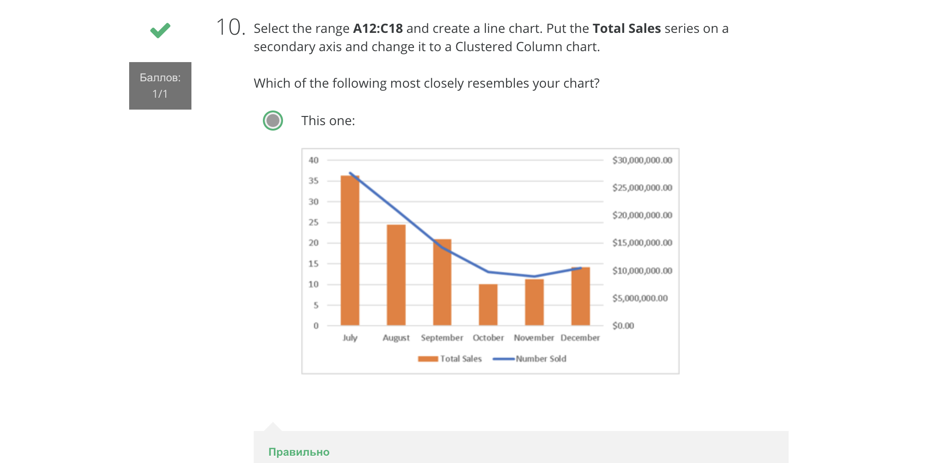)  
  
11.1 In your new chart select the Number Sold series and add a trend line. Show the R² value. Compare the results you get from the different trend line options.

Which of the following trendline options yields the best R² value?

**(Logarithmic)**  
  
12.1 Change your trendline to a Polynomial Order 2.

What R² value does the Polynomial Order 2 show?

*Type 0. followed by 4 digits e.g. 0.6789.*

**(0.9933)**

# **Тест 5** Test your Skills: Tables

1.1 The attached workbook is needed to answer all the questions associated with this quiz. Please download the file and open it in Excel before you start answering the questions below.  
**(NO)**

2.1 Convert the Discount Code data (O13:P15) to a table.

Add a new record directly below the table as follows:  
Code: C  
%: 15%  
What is the corrected Average Discount % shown in P19?  
**(6,76)**

3.1 Convert the Homewares Inventory data to a table. Apply the table style White, Table Style Light 18. Turn off banded rows and turn on banded columns.

Which of the following most closely resembles your table?

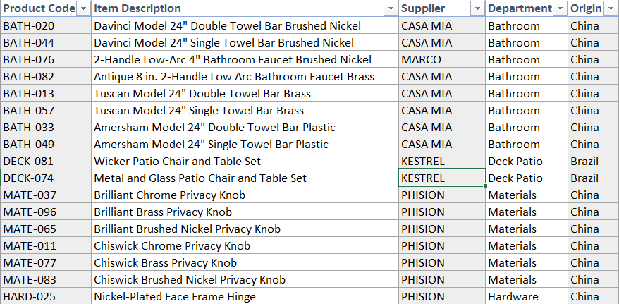

**(Вверху картинка)**

4.1 Turn on the Total Row. Change the calculation for the Retail Price column to calculate the average retail price.

What is the average retail price?  
**(101.05)**

5.1 The In Stock column displays the number of items in stock for each product. Using the Total Row to add a calculation, how many items are currently in stock for all products?

**(1428)**

6.1 You have been informed that there may be duplicates in the data. Use the Remove Duplicates tool to remove any duplicate entries.

What is the corrected average retail price?  
**(104.13)**7.1 You need to find out which products need re-ordering most urgently. Sort the data by the column In Stock from Smallest to Largest.  
Enter the full product code for the product with the smallest number in stock.  
**(HARD-015)**

8.1 You are doing an audit of products supplied by the company Kestrel. Filter the data by the supplier Kestrel.

What is the updated value for the total number of items in stock now?  
**()**

9.1 Clear the filter on Supplier and add a new filter to get the top 5% of stock items by retail price.

What is the average retail price for these items?  
**()**

10.1 Clear all filters and turn off the total row. In the first empty row add the following record:

|  |  |
| --- | --- |
| Product Code | HARD-026 |
| Item Description | Chrome-Plated Face Frame Hinge |
| Supplier | PHISION |
| Department | Hardware |
| Origin | China |
| Location | Showroom |
| Rack | 02 |
| In Stock | 100 |
| Target Level | 100 |
| Reorder Level | 50 |
| Discount % | (*Copy down from the row above*) |
| Unit Cost | $6.32 |
| Retail Price | $7.49 |

Turn the total row back on. What is the updated Average Retail Price?  
**(102.27)**

**Тест 6** Test your Skills: Pivot Tables, Charts and Slicers

1.1 The attached workbook is needed to answer all the questions associated with this quiz. Before creating pivot tables it is always a good idea to put your data into a table. Convert the sales data to a table. Rename the table Sales. Turn on the Total Row and in the total row in the Price Paid column select Average to get the average price paid.

What was the Average Price Paid?  
**(589287.28)**

2.1 Turn off the Total Row. Create a Pivot Table in a new sheet to show the Total Price Paid for each Town.

What does the Pivot Table show as a total for Southall?  
**(4505138)**

3.1 Modify the Pivot Table to show Year Sold in the columns.

What were the total sales for Northholt for 2016?  
**(4240650)**

4.1 Change the value field settings to show the calculated values as a percentage of the Grand Total.

What percentage is shown for London in 2014?  
**(33.92)**

5.1 Still working in Sheet1, click into cell A15, and create a Pivot Table from your Sales data that shows total Price Paid for each Property Type. Rename the pivot PropertyType.

What was the Total Price Paid for Semi properties  
**(72298550)**

6.1 In the PropertyType pivot change the Summarise Values By setting to use a Count instead of a Sum.

How many Flats were sold

**(431)**

7.1 Click in the PropertyType pivot and in the PivotTable field settings tick the Estate Type checkbox.

How many Leasehold Terraced properties were sold?

**(10)**

8.1 In the PropertyType pivot add Year Sold to the Filters section in the PivotTable field list. Change the filter to only show properties sold in 2014 and 2015.

How many Freehold Terraced properties were sold in this time period?  
**(162)**

9.1 Still working in the PropertyType pivot, clear all filters, remove Year Sold from the Filter area and remove Property Type from the Rows area. Add Deed Date to the column area and group by Year and Quarter. If necessary expand the Year group for 2015.

How many Freehold properties sold in Quarter 3 of 2015?

**()**

10.1 Add a slicer to filter the PropertyType pivot by Postcode. Select all postcodes that begin with UB1or UB2.

How many Leasehold properties sold in Quarter 2 of 2015 for these postcodes?

**()**

## Final Assessment

1.1In order to solve this assignment, please follow the steps below:

STEP 1: Download the Excel workbook, save it on your device and open it.

STEP 2: Follow the instructions in order to answer the quiz questions. You will need to perform each task on your worksheet and then type in the solution into the Quiz answer boxes.

Good luck with this final assessment for the course. You have worked hard to get here. Trust your skills and get into it.

Have a look at the first 3 worksheets, they contain student marks for 3 terms. Now go to the Final Marks worksheet and use 3D-Formulas to get Benjamin Abbot's class test average for terms 1, 2 and 4. Copy the formula across to I4 and then down for the rest of the students. What was the Average Final Mark (as shown in cell M4)?

**(62.6)**

2.1 Note that you have a sheet called Marks Term 3 but it is not in the right position. Move this sheet to sit between the sheets Marks Term 2 and Marks Term 4. Check the Final Marks Sheet, what is the average Final Mark now?

**(62.7)**

3.1 Select the range A3:J465 and use Create from Selection to name each of the columns of data. This should have corrected the missing stats figures. What was the median Final Mark (M5)?

**(64.0)**

4.1 Select the range L20:M26 and name it Grades. This should have corrected the grades calculations. What grade did Olivia Jones get?

**(C!)**

5.1 In M10 use a formula to calculate the total number of Fail grades. Copy the formula down to M16. Note cell P4 which displays the Total Number of students who achieved a "C" should have changed colour. What colour is the cell?

**(Yellow)**

6.1 In N10 create a mixed reference formula that will count how many of Mr Chang's students got a Fail. Drag the formula down and across to complete the table. Observe P5, which shows the number of A's achieved by Ms Sekibo's students. It should have changed colour. What colour is it now?

**(BLUE)**

7.1 Have a look at the worksheets Absences Term 1 through to Term 4, they contain a list of dates that students were absent. We need to create a summary showing a count of how many days each student was absent. Go to the Absence Report Sheet. Click in A4, and then use the Consolidate tool to consolidate the data on the other Absences sheets. The results look a bit odd, but that is because the count values have been formatted as dates. Change the formatting to General or Number. Sort the data by Total Absences. How many students were absent for more than 15 days?

**()**

8.1 Go to the Student Report worksheet. Some of the information still needs to be completed. Create a formula in D4 to return the Student's full name, this should be First Name followed by a space and then Surname. The case must also be corrected so that all words start with a capital letter but everything else is in lower case e.g., Benjamin Abbot. Copy the formula down for all the other students. What is the value of the check digit in S4?

**()**

9.1 In E4 create a formula to generate the student email address. This should be their first initial, followed by their surname, followed by "@newcollege.com", and must all be in lower case, e.g. babbot@newcollege.com. Copy the formula down for all the other students. What is the value of the check digit in S5?

**()**

10.1 The last two digits of the student number indicate the year the student enrolled. In F4 create a formula that will put "20" followed by the last two digits of the Student ID, e.g. 2015. Copy the formula down for all the other students. What is the value of the check digit in S6?

**()**

11.1 We would like to get an idea of how students have progressed over the year. Click in M4 and create a sparkline line chart that charts the data in cells I4:L4. Copy the sparkline down for all the other students. Change the sparkline to show the highest point. Which of these sparklines represents Olivia Jones' data?

This:



**()**

12.1 Convert the data in the Student Report Sheet to a table. Name the table Report and change the style to Green Table Style Medium 21. Which of the following styles did you choose?

**(This:)**



13.1 With the table still selected, turn on the Total Row. What are the Total Fees Owing?

**()**

14.1 In the Total Row in the Year Enrolled column, chose the correct function to calculate the number of all students enrolled. How many are there?

**()**

15.1 Filter the table to show all Distance Learning students who owe more than $9,000. How many are there?

**()**

16.1 We would like to compare the results for different types of students. Clear all filters. Use the data in the table to create a pivot table (in a new sheet) that shows Grade in the Row Labels, Student Type in the Column Labels, and Count of Grade in the Values section. How many A's did the Part Time Students get?

**()**

17.1 Change the pivot to show the values as a percentage of the column total. What percentage of Part Time students failed?

**()**

18.1 Mr Chang has observed that the students attending the college seem to be increasingly more able and more motivated. He would like to see if there is a pattern in the results based on enrolment date. Click in A17 and create another pivot table to show the average final mark by enrolment date. Add a filter field and change the filter to only show data for Mr Chang. Format the values to only show 2 decimal places. What was the Average mark for 2017?

**()**

19.1 Create a Clustered Column pivot chart using the data in the second pivot table (if you have Excel for Mac select the data in A17:B20 and just create a regular chart). Add a linear trendline and display the R-squared value on the chart. What is the R-squared value?

**()**

20.1Have a look at the other trend line options and select the one that returns the best R-squared value. Forecast forward for 1 period. If the trend continues, students who enrol in 2018 are expected to get an average result closest to…

**(73)**